Introduction
Bean Boutique coffee shop is a local business offering several services, being offered locally, now it aims at breaking its limits by expanding its presence online to reach more customers.
The aim of the development is to develop a user friendly and responsive website, functional on different devices and web browsers.

BEANBOUTIQUE WEB DEVELOPMENT

HTML
Hyper Text Mark-up Language is a backbone of the website. It contains all content viewed on the website. It is structured using HTML tags. These tags define what type of content is to be displayed. Bean Boutique Coffee shop uses HTML5, a recent update of HTML. Bean Boutique consists of six interlinked structured pages.

Home page
The Home page welcomes customers with miscellaneous contents available at Bean Boutique
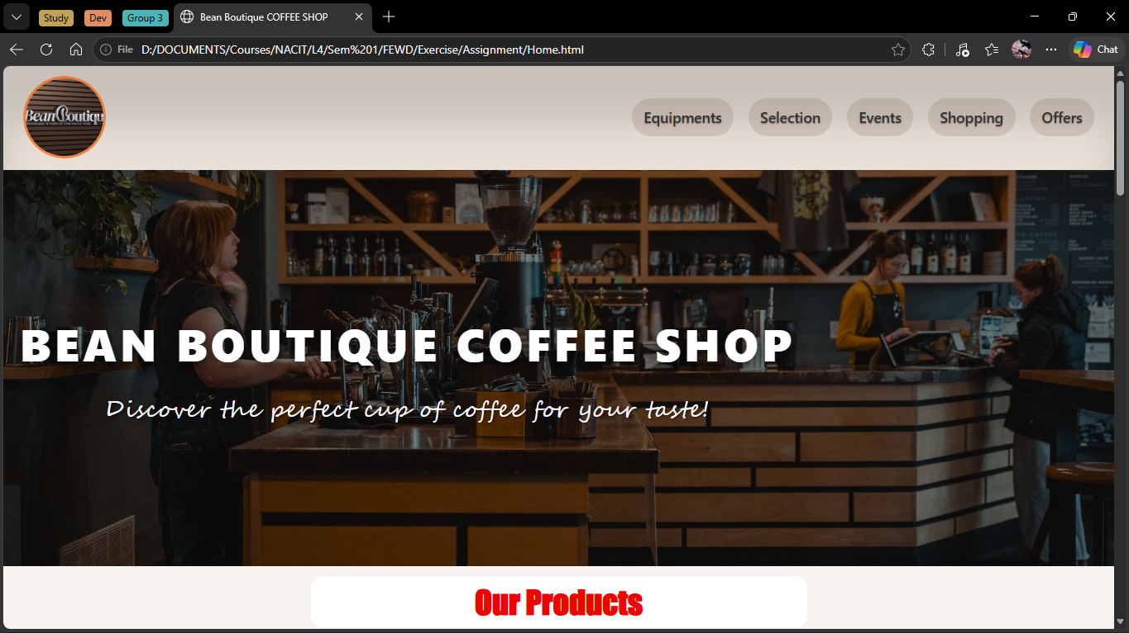

Equipments Page

The page showcases coffee brewing machines and equipment sold at Bean Boutique
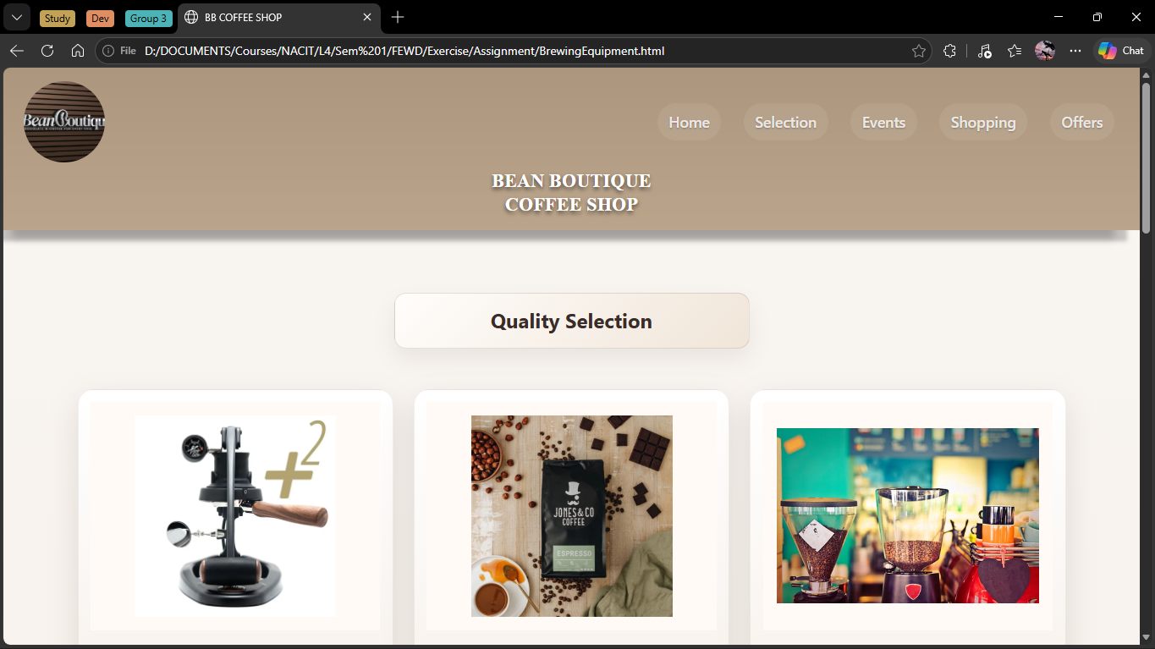

Selection Page
This page displays different coffee brands sold at Bean boutique.
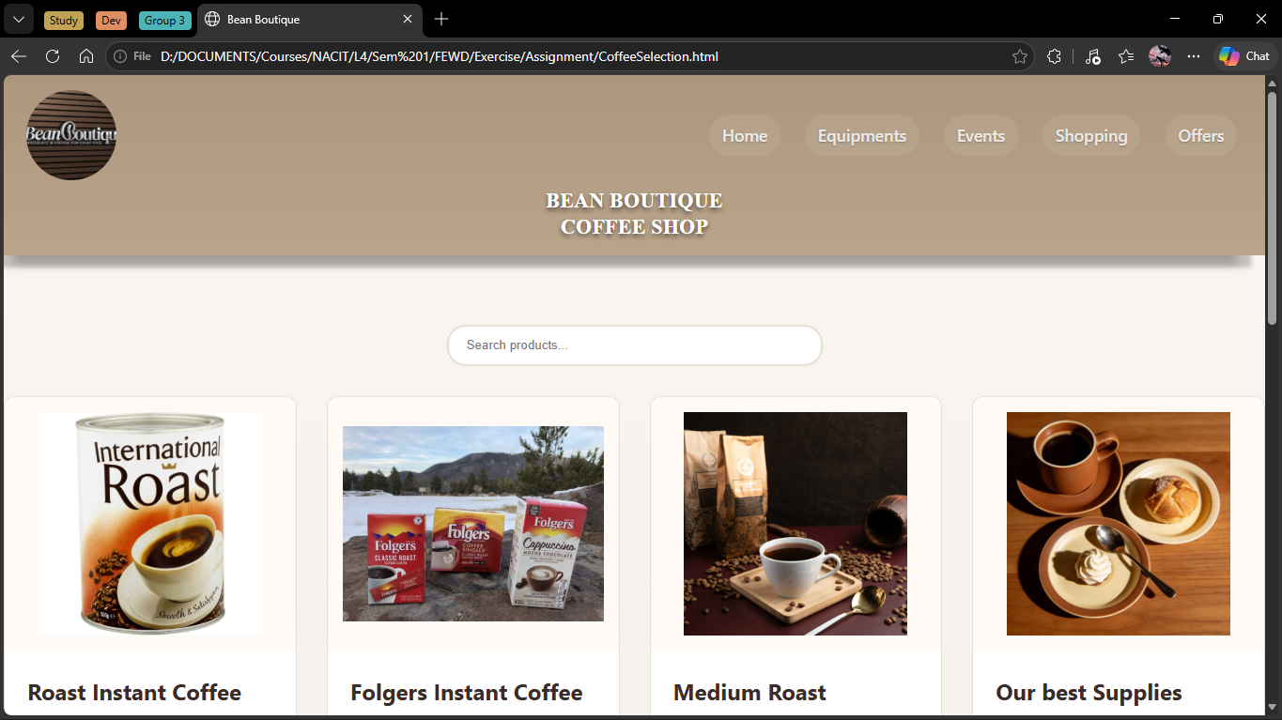

Shopping Page
This page contains selected items added to the cart displayed in table form and additional items.
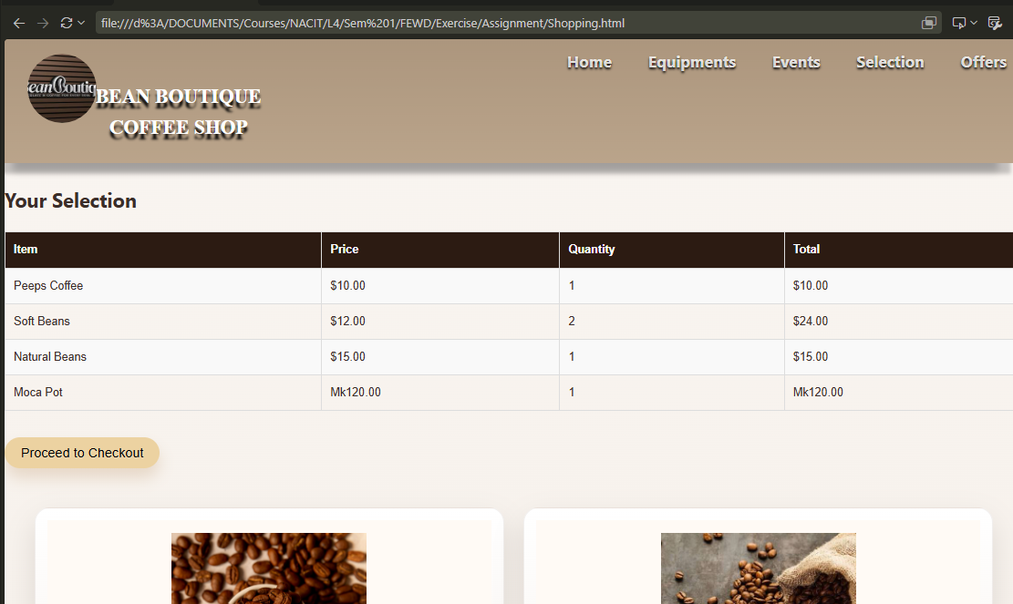

Events Page
This page shows different events and workshops available at Bean Boutique.
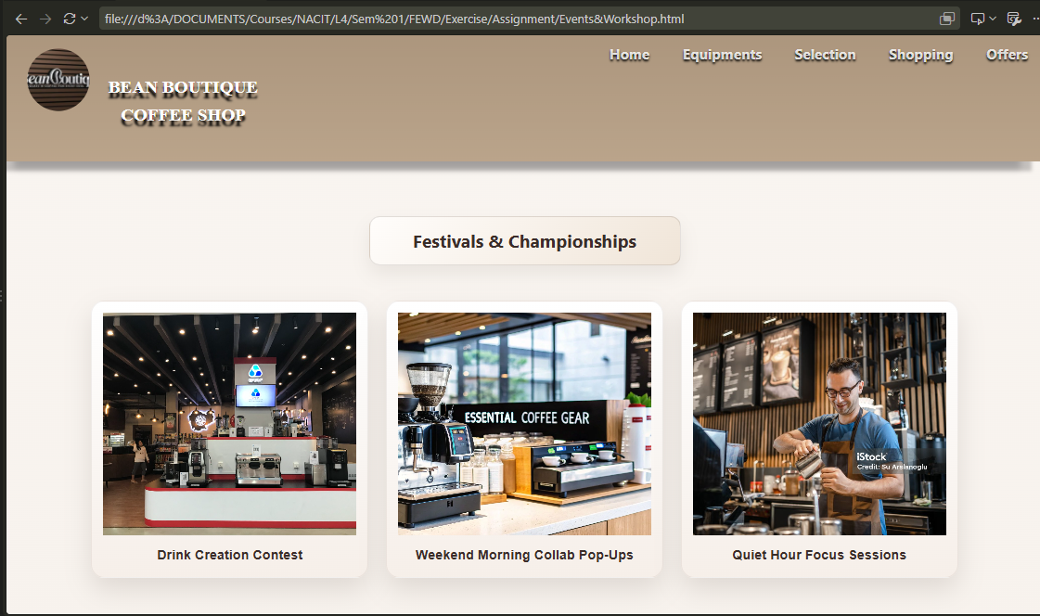

Offers page
This page shows addition services a customer can prefer to join.
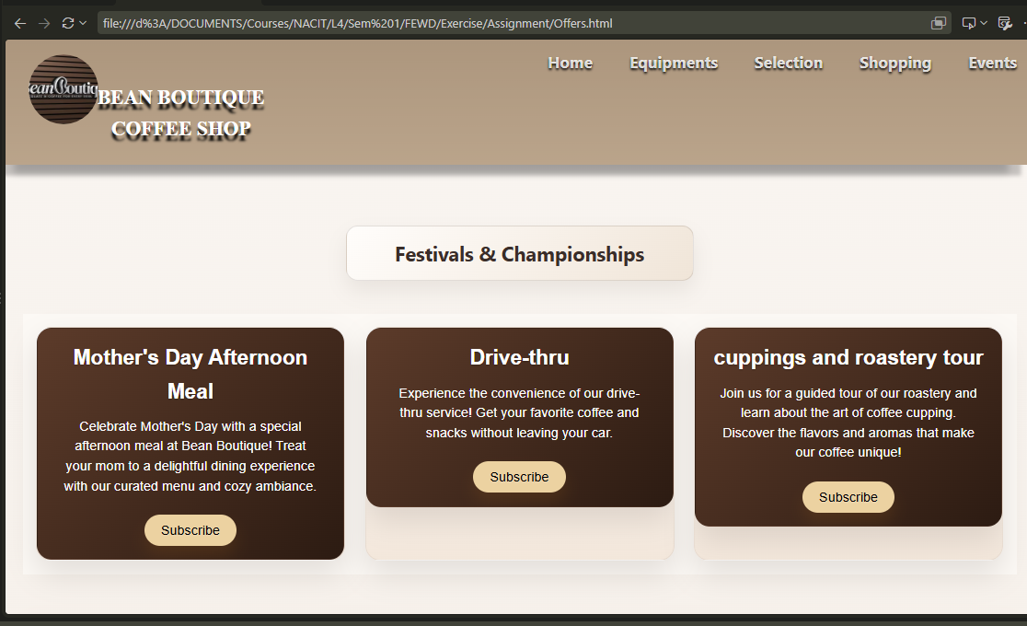

Cascading Style Sheet
Cascading Style Sheet (CSS), a language used to style HTML pages. It tells the browser how to display the HTML content. Each HTML file in Bean Boutique project is linked to the external CSS. 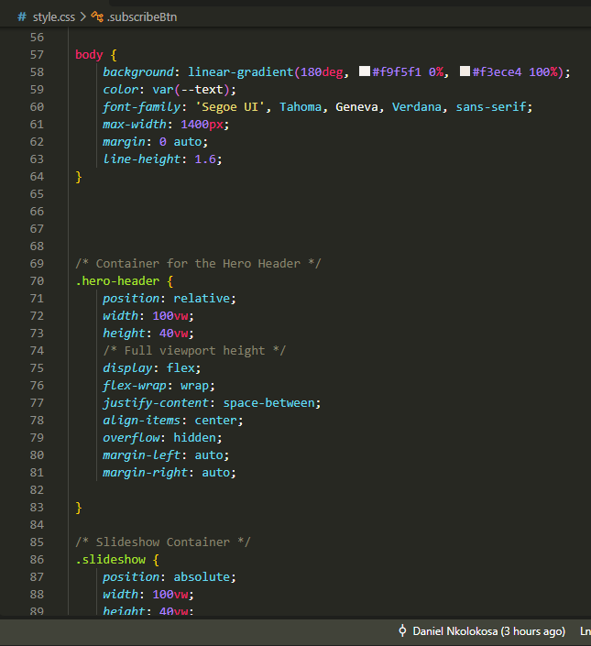

Home page
The home page is styled that it contains slide show.

Equipment page

Selection Page

Shopping page

Offers page

Events Page

Website test report
The website was tested using W3C validation tool. The test was aimed at evaluating and checking if the website can easily be accessible on different web browsers, devices and to disabled people and it aligns with rules of developing webpages.
- Keyboard Navigation: All controls worked perfectly, popups, forms worked without any error.
- Structural tags were resolved and well implemented allowing screen leaders to announce changes.
- Multiple browsers show responsiveness of the website. Desktop Chrome, Microsoft edge and mobile browser Chrome were used to test the responsiveness of the website. All tests passed with little visual layout discrepancy.
The discrepancy was solved by removing fixed measurements Width and heights.

In HTML testing the shopping page two errors were identified missing div end tags.
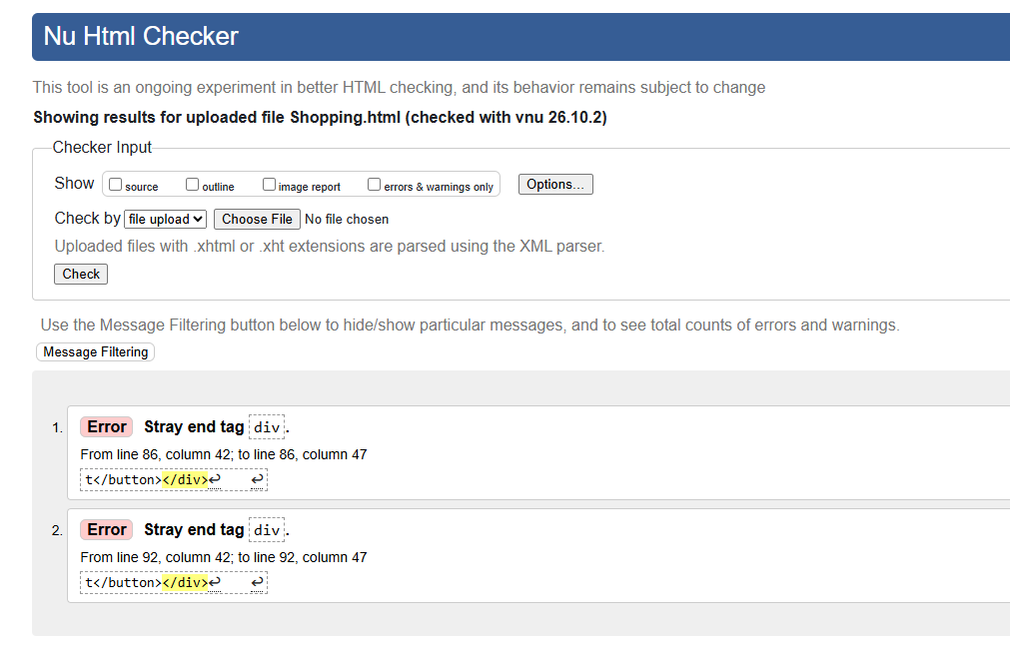

In CSS testing four errors were identified.
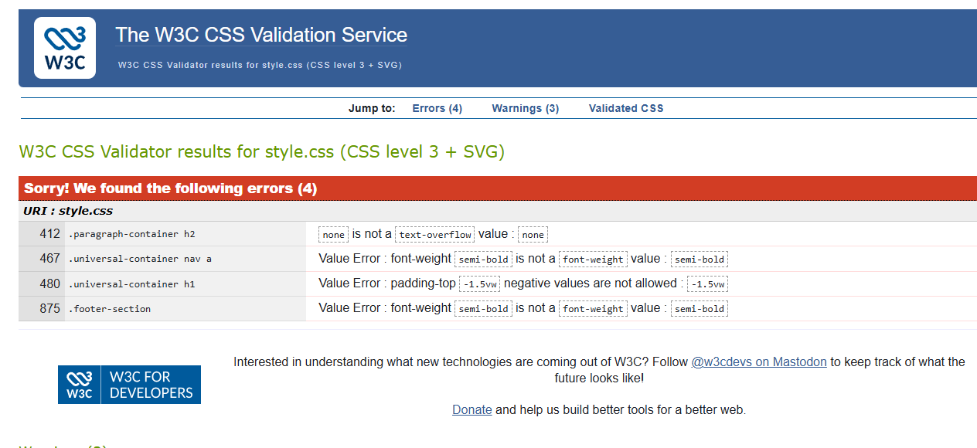
Errors identified:
- text-overflow = none
-Text overflow is a CSS property that styles how hidden or overflowing text should be displayed. It is useful to render text to respond in different devices and web browser. The property was set to non which is not a value for text-overflow.

- Font-weight = semi-bold
-Text size was assigned to semi bold which is not a proper value for setting font weight.
- Padding = negative value
- Padding values was set to negative value, this affects some browsers when trying to display.
The identified errors were resolved by adding appropriate values to the properties.

Browser testing and Differences

Desktop Microsoft Edge: Perfect layout rendering with images not losing quality and size, CSS grid and flex worked well. Scrolling transitioning worked well with no layout shifting.

Mobile Chrome: Responded with single column layout to fit the screen size, scrolling was smooth with no layout breaking.

The website passed most useful requirements. Struggled only with few discrepancies due to fixed width and heights. Applied several units to test the effects. Height shifted to pixels (PX), Viewport width (VW) and Small viewport height (SVH) to check the responsiveness of the webpages.
Finally most measurements were fixed to Root EM (rem). Root EM (rem) is a measurement available in most browsers allowing the website to best perform in all web browsers and devices.

World Wide Web Consortium
W3C is an organisation that creates standards and guidelines for the World Wide Web (WWW). These standards and guidelines help developers to develop websites accessible to all people, platforms and devices. They promote and maintain interoperability across different web browsers, software compatibility, guarantees accessibility for users with different disabilities.

Critical Evaluation

Back-end Technology
The development of Bean Boutique website involved the use of front end languages HTML, CSS and JavaScript. Front End mainly determines the appearance and behaviour of the website to the user on browsers and devices. For Bean Boutique to start working as a commercial webpage it will need the use of back end technology. Back end involves the use of languages and tools responsible for managing databases and user credentials. Back end programming languages such as PHP for server management, or Node.js for also managing servers can be used. Languages such as MySQL can be used for database management.

The server would be responsible for hosting the website by keeping and managing documents for the website, images, descriptions and other stock balances stored in the database.
For user authentication, user security is one of the most useful objective required to be handled with profession. User privacy and security of their data is recommended. This can be done by using encryption or hashing algorithm. A method of hiding user credentials from unauthorised users. The use of other technologies like REST API can be useful since customers will be processing transaction directly on the website. This method protects user payment details on the website.

Web plugins
Three client side plugins have been added to the website. These plugins help in boosting the online presence of the website and its integrity.
- Social media widget: The Facebook widget has been added to promote the site on social media by showing contents created by followers of the business. It is suitable because the content generated boost and make it discoverable on search engines.
- Google maps: This plugin has been added in events page to display Bean Boutique address as well as location where upcoming Events are going to happen. It is added to allow customers to know the venue of events and give them directions.
- Security Verification: Google reCAPTCHA has been added to the website. This plugin will help in distinguishing between robots and humans by examining the traffic data.

Version Control System
A version control System is a software that enables developers keep record of changes of their projects and track the progress. It also enables developers to make collaborations by allowing multiple developers to work on the same document. Git and GitHub is one of the version control systems widely used. It has the following benefits:
- Help keep track of versions by keeping each change in repositories.
- Help identifying bugs made and allowing programmers to go back to the previous version.
- Help in code safety by allowing developers make new changes to code while keeping the main code untampered.
- Allow code review where collaborated colleagues can examine the proposed changes in order to make sure it fits the requirements.
- It also provide a remote backup storage.

Front End Frameworks and Bootstrap

Front-end frameworks
These are ready made sample templates that provide a start up for developers. It comprises of front end languages only like HTML, CSS and JavaScript. These frameworks include responsive code, user interfaces, and stylesheets. It has several benefits:
- Help developers to build websites fast without starting from scratch.
- Provide web consistent look thereby enhancing user experience
- Help avoid common mistakes.
(geeksforgeeks, 2026)

Bootstrap
Bootstrap is a front end framework used by developers to fast develop websites without starting from scratch. It includes HTML and CSS designed for better website output. It consists designs for forms, buttons, navigation and typographies.
It is of huge benefit to use bootstrap. Benefits include:
- It is easy to use
- Bootstrap is compatible with modern browsers
- Consists of responsive web architectures

Unique selling points
The main purpose of web development is to design and develop a unique and attractive web page. In Bean Boutique website some technologies are added to improve the usability of the website. One of the features include search feature which improve user experience to find products and services offered at Bean Boutique.
There are also improvements that can be added to the website for better usability.
- Implementing dark/ light mode switch. This can increase user accessibility for user with visual problems.
- Building a progressive web application. This can make the website to ha a feel similar to an application with features such as offline access and push notifications.

